EXPERIMENT NO-17: SUM OF INTEGERS FROM 1 TO N
Aim
To implement a Prolog program that calculates the sum of integers from 1 to n using recursion.
Algorithm
- Define a base case: the sum of integers from 1 to 1 is 1.
- Define a recursive case:
  - The sum of integers from 1 to N is equal to N plus the sum of integers from 1 to (N-1).
- Use recursion to compute the result.
- Query the program with a value of n to get the sum.
Prolog Code
prolog
% Sum of integers from 1 to N

% Base case
sum(1, 1).

% Recursive case
sum(N, Result) :-
N > 1,
N1 is N - 1,
sum(N1, SubResult),
Result is N + SubResult.
Output
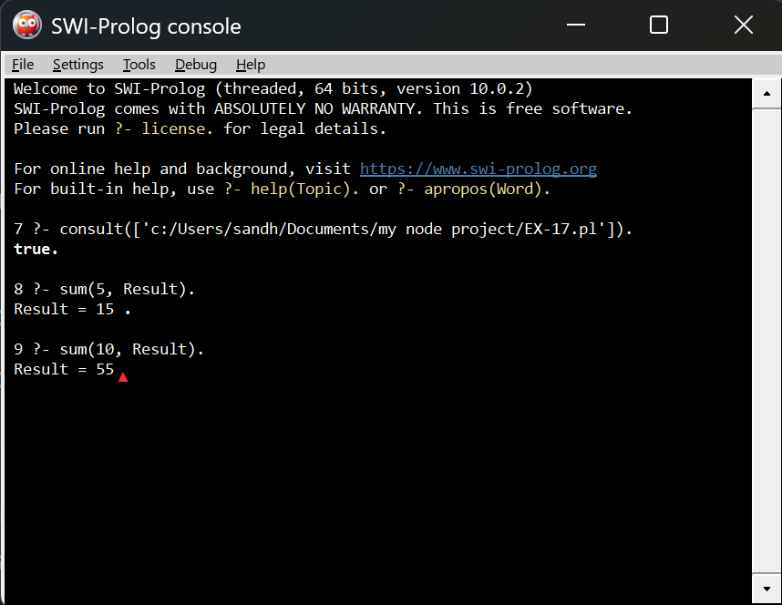
Result
The Prolog program successfully computes the sum of integers from 1 to n using recursion. For example:
- Sum from 1 to 5 = 15
- Sum from 1 to 10 = 55
Would you like me to also show you a tail-recursive version (more efficient, avoids stack buildup) so you can compare both approaches?

